**HTML | rowspan Attribute**

Last Updated : 01 Aug, 2022

 The **HTML <th> rowspan Attribute** is used to specify how many numbers of header row cell will span.

**Syntax:**

<th rowspan="number">

**Attribute Value:**

* **number:** It contains the numeric value which specifies the number of  rows the header cell should span.

**Example:**

**html**

|  |
| --- |
| <!DOCTYPE html>  <html>    <head>      <title>          HTML th rowspan Attribute      </title>  </head>    <body>      <h1>GeeksforGeeks</h1>        <h2>HTML th rowspan Attribute</h2>        <table border="1" width="500">          <tr>              <th>NAME</th>              <th rowspan="3">AGE</th>              <th>BRANCH</th>          </tr>            <tr>              <td>BITTU</td>              <td>CSE</td>          </tr>            <tr>              <td>RAKESH</td>              <td>EC</td>          </tr>      </table>  </body>    </html> |

**Output:**

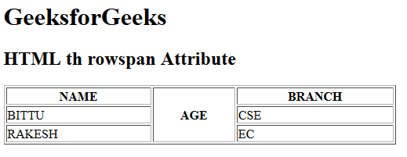

**Supported Browsers:** The browser supported by **HTML <th> rowspan attribute** are listed below: